Answer the following questions:
- What is sentiment analysis?
- Where can we get reviews?
- Give me examples of the importance of sentiment.
- What are sentiment analysis steps?
- How do we know if we have a good model?

Implement Sentiment Analysis using the below Lexicon for the following sentences:

- The affluent vice president, known for her hard work and intellectual prowess, navigated the suspect waters of politics with instinctive grace, her vivacious spirit winning over even the most deprived of hearts.
- A ghastly grimace contorted the awful teacher's face as the ignorant student posed a bubbling question that challenged her unwavering authority, sending a ripple of tense anticipation through the classroom.
- Amidst the unpleasant stench and sticky residue of the garbage dump, a vivacious child, her eyes ablaze with dazzling innocence, unearthed a marvelous treasure – a discarded toy that sparked angelic joy in her heart.
- Though stuck in the throes of infernal grief, the novel writer, fueled by an effervescent imagination, channeled his insane sorrow into a stirring masterpiece, a testament to the stupendous resilience of the human spirit.
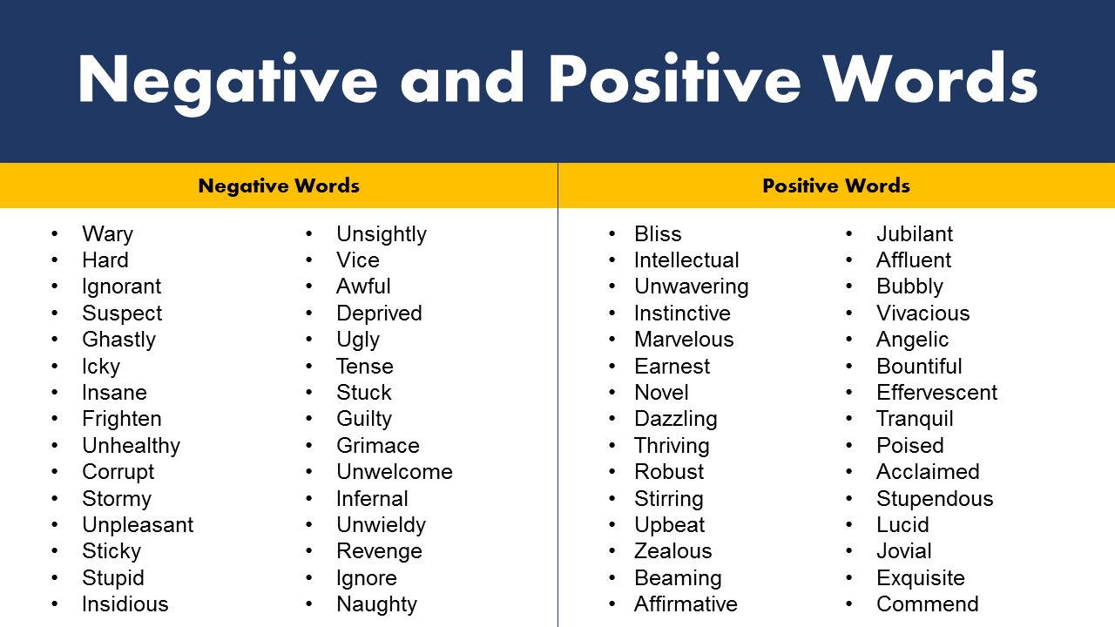

Implement the following code in Python along with the codes supplied in slides.
import nltk
from sklearn.feature_extraction.text import CountVectorizer from sklearn.model_selection import train_test_split from sklearn.naive_bayes import MultinomialNB
from sklearn.metrics import accuracy_score, classification_report, confusion_matrix

# Download NLTK stopwords (if not already downloaded) nltk.download('stopwords')

# Sample labeled dataset for training (you should replace this with your own dataset) data = [
("I love this product", "positive"),
("This is terrible", "negative"),
("I am not sure about this", "neutral"),
# Add more examples as needed
]

# Split the data into features (X) and labels (y)
X, y = zip(*data)

# Split the data into training and testing sets
X_train, X_test, y_train, y_test = train_test_split(X, y, test_size=0.2, random_state=42)

# Vectorize the text data using CountVectorizer vectorizer = CountVectorizer(stop_words='english')
X_train_counts = vectorizer.fit_transform(X_train)
X_test_counts = vectorizer.transform(X_test)

# Train a Naive Bayes classifier classifier = MultinomialNB()
classifier.fit(X_train_counts, y_train)

# Make predictions on the test set
predictions = classifier.predict(X_test_counts)

# Evaluate the model accuracy = accuracy_score(y_test, predictions) conf_matrix = confusion_matrix(y_test, predictions) class_report = classification_report(y_test, predictions)

# Print results
print(f"Accuracy: {accuracy:.2f}") print("\nConfusion Matrix:") print(conf_matrix)
print("\nClassification Report:") print(class_report)

Answers
1) What is sentiment analysis?
Sentiment analysis is an NLP technique used to identify and classify opinions or emotions in text as positive, negative, or neutral.
2) Where can we get reviews?
- Social media (Twitter/X, Instagram)
- E-commerce sites (Amazon, eBay)
- Review platforms (Google Reviews, Trustpilot)
- Surveys and feedback forms

3) Importance of sentiment (examples):
- Companies analyze customer reviews to improve products
- Governments analyze public opinion on policies
- Brands monitor reputation on social media

4) Sentiment analysis steps:
- Data collection
- Text preprocessing (tokenization, stop-word removal)
- Feature extraction (Bag of Words / TF-IDF)
- Model training
- Evaluation

5) How do we know if we have a good model?
By checking accuracy, precision, recall, F1-score, and the confusion matrix on unseen test data.

Lexicon-Based Sentiment Analysis (Given Sentences)
Sentence 1
Sentiment: Positive

Sentence 2
Sentiment: Negative
Sentence 3
Sentiment: Positive

Sentence 4
Sentiment: Positive

